

|  |
| --- |
|  |
| LUXURY STAY Hospitality |
| USER MANUAL |

SIR ALI IMRAN HUSSAIN | MISS SANA YOUSUF

|  |  |  |  |  |  |  |  |  |  |  |
| --- | --- | --- | --- | --- | --- | --- | --- | --- | --- | --- |
| |  |  | | --- | --- | | Enrollment ID | Student Name | | Student1346661 | YAHYA AHMED MUGHAL | | Student1365428 | AZHAR SHAH | | Student1370719 | CHRIS RIAZ | | Student1365416 | ABDUL MUGHNI SIDDIQUI | |
| SIR ALI IMRAN HUSSAIN | MISS SANA YOUSUF | |



|  |  |
| --- | --- |
|  | Decorative |
| BACKGROUND |
| Luxury Stay Hospitality, a high-end hotel chain known for its exceptional service and luxurious accommodations. With a network of hotels in various locations, Luxury Stay aims to revolutionize its operational efficiency by implementing a cutting-edge Hotel Management System (HMS).  Luxury Stay envisions a modern, scalable, and user-friendly Hotel Management System to transform its operations. The system will streamline workflows, enhance guest experiences, and provide insightful data for strategic decision-making. |

|  |  |
| --- | --- |
|  | Decorative |
| FEATURES |
| Admin PANEL  * Admin can add, edit, or delete employee roles and assign them to staff. * Admin manages employee records, including adding, editing, and deleting employees. * Admin can manage hotel floors (add, edit, delete) and assign rooms. * Admin manages room types (add, edit, delete), including pricing and features. * Admin manages rooms (add, edit, delete) and updates room statuses. * Admin can view booking statistics, revenue reports, and occupancy trends.  Receptionist  * Receptionist manages guest records (add, edit, view, delete). * Receptionist books rooms for guests and confirms availability. * Receptionist takes food orders and manages delivery. * Receptionist edits or cancels bookings and updates check-in/check-out details. * Receptionist generates invoices for guests, including room and food charges..  HOUSEKEEPING  * Housekeeping updates room status from "cleaning" to "available" after cleaning. |



**ADMIN PANEL**

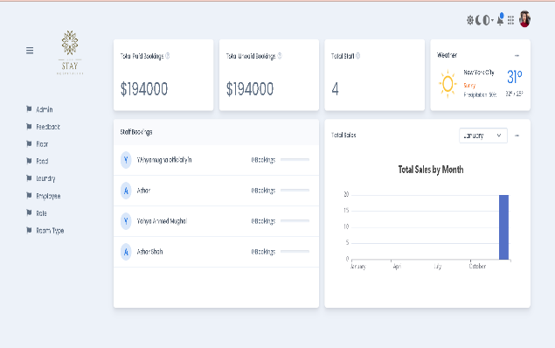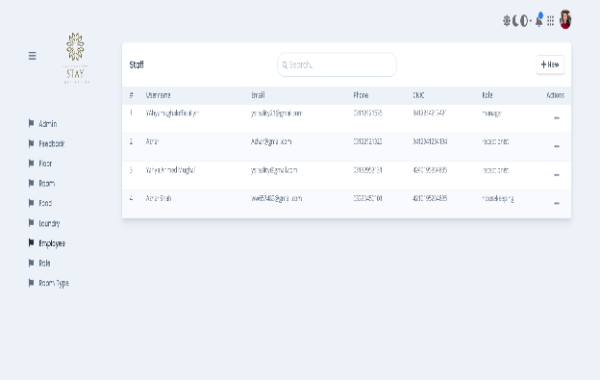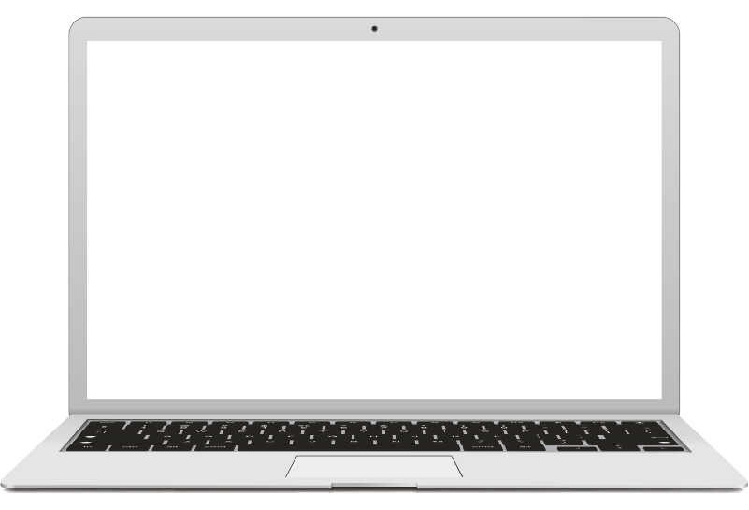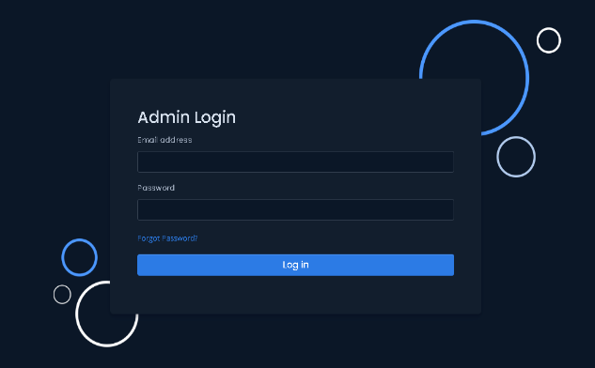

**CRUDs**

**Analytics**

**Login**



**STAFF PANEL**

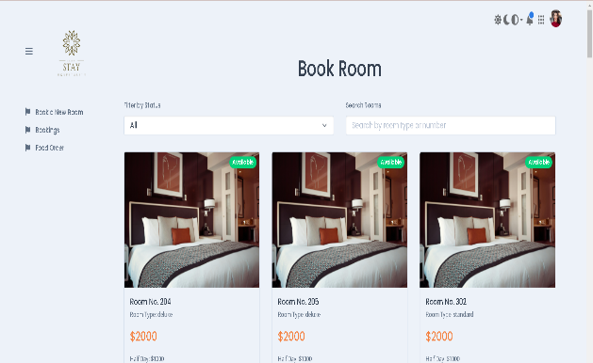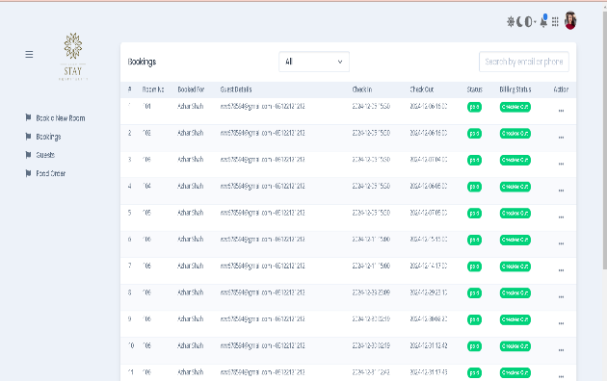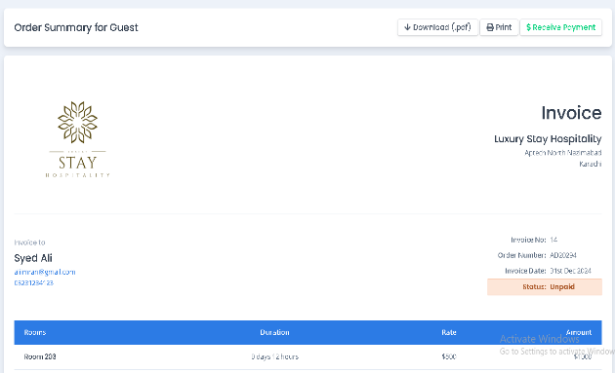

**Booking Management**

**Invoice Creation**

**Room Booking**